**Steps to Create Your Business Development Video**

**Overview:**

1. You have provided us your video and music selection so that we can create for you the first and last 15 seconds of your video. It will take us 7 days to send to you these files.
2. The middle part of your video, you will record using your webcam (or smart phone). We will give you a script and tell you how to do that below.
3. Then the three segments (the 15-second intro video, your recorded message for the month and the 15-second exit video with your contact information) will get combined to make one video file.
4. You will upload that file (as explained below) and get a link. You will use that link in an email to your clients and prospects so they can watch your video.

We hope you’re as excited as we are about you creating, publishing and sending your video updates to your prospects, clients and centers of influence. Below is a step-by-step, easy to follow video tutorial on how to get this done. Each video tutorial explains how you will create your Business Development Video. Once you learn the process, in 30 minutes each month, you will be able to create a professional business development video to send to your clients and prospects

Each video tutorial below is from 3 to 7 minutes long. Best practice is to watch one entire video all the way through. Then, watch that video again, this time, stopping on each step until you implement the instruction.

**Very important: the first time you learn the process will be your largest time investment (probably two hours). Thereafter, you will be able to produce a video every month in about 30 minutes.**

**If you do not have facility downloading software, uploading files, using PC and Internet common tools, PLEASE find 14-year-old to help you. While we would be happy to assist you, it is impossible without being at your location for these following steps.**

1. Video 1 is an overview of the entire process it gives you a sense of how easy this really is. In it, we also show you the inexpensive equipment you will use (most of which you already have). Please [watch the overview video now](https://www.screencast.com/t/JZw0BuboL). 3 minutes. Once you have watched that video, proceed to the next video.
2. Video 2 explains how to set up your office for a great looking video clip. We also tell you how to use your phone as a free teleprompter so you can read your script (without looking like you are). [Watch the second video now](https://www.screencast.com/t/MvPXESDicDh6). 6 minutes. Once you have set up your office and practiced using your phone as a teleprompter, proceed to the next video.
3. Video 3 walks you through recording your video. Watch this video now and [record your presentation.](https://www.screencast.com/t/FkeyeIUmUHe)  5 minutes.
4. The next video is optional. If you like, you can use PowerPoint to edit out certain extraneous parts of your video clip. If you don’t need to do that, you can skip this step. But if you want to do so, here’s the video that will show you how. [Watch this video now](https://www.screencast.com/t/dXLL5BYgX5u) and go to the next step when you are done. 4 minutes.
5. This next video shows you how to use a free piece of software to join the video clip you just recorded to the intro and outro we created for you. [Watch this video now](https://www.screencast.com/t/zZJOCgvWmR5x) and go to the next step when you are done. 2 minutes.

This is what will happen in this step. In this step, you use free software to join together the first and last 15 seconds, that we created for you, and the video clip that you recorded

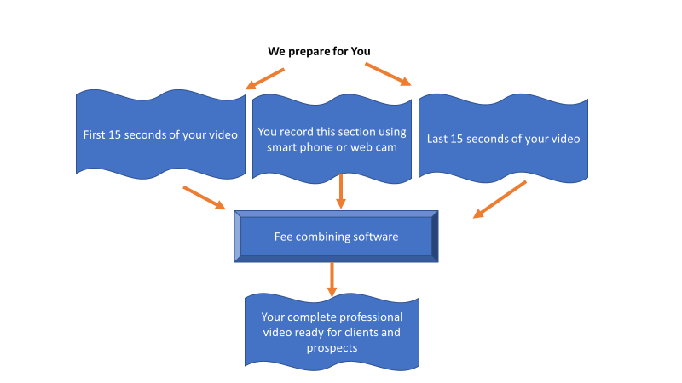

1. In the next video, you will set up a FREE account with Screencast and upload your video. Once you upload your video, you will get a link to use in an email to send to your clients and prospects. [Watch this video now](https://www.screencast.com/t/MI5ocqSbN) and go to the next step when you are done. 2 minutes.
2. Your last step is to send your prospects, clients and centers of influence a link to the video you uploaded. This video shows you how to do that. [Please watch this now](https://www.screencast.com/t/j9KYdxiF). 4 minutes.

Good luck! Please contact [neal@advisor-newsletter.com](mailto:neal@advisor-newsletter.com) for support.